Setting up Slack Channel for Configuring Build Notifications

Step 1: Log in to the Jenkins CI tool and create a freestyle job

- Open the browser, go to the Jenkins Dashboard by typing localhost:8080 in your browser, provide the credentials, and click the Sign in button
Click on the New Item option as shown in the screenshot below:
Enter a desired name for the project, select Freestyle project, and then click on OK as shown in the screenshot below:

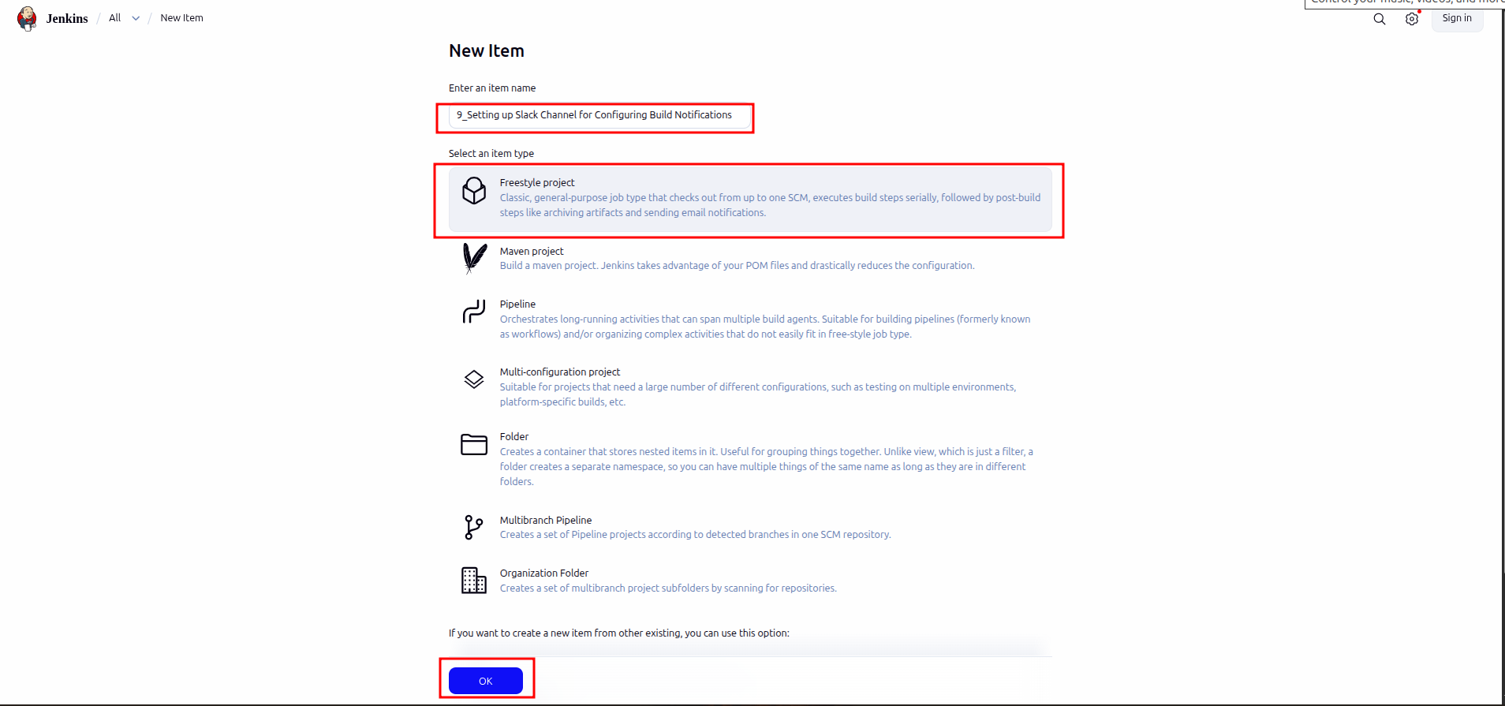

- Click on Save button as shown in the screenshot below:
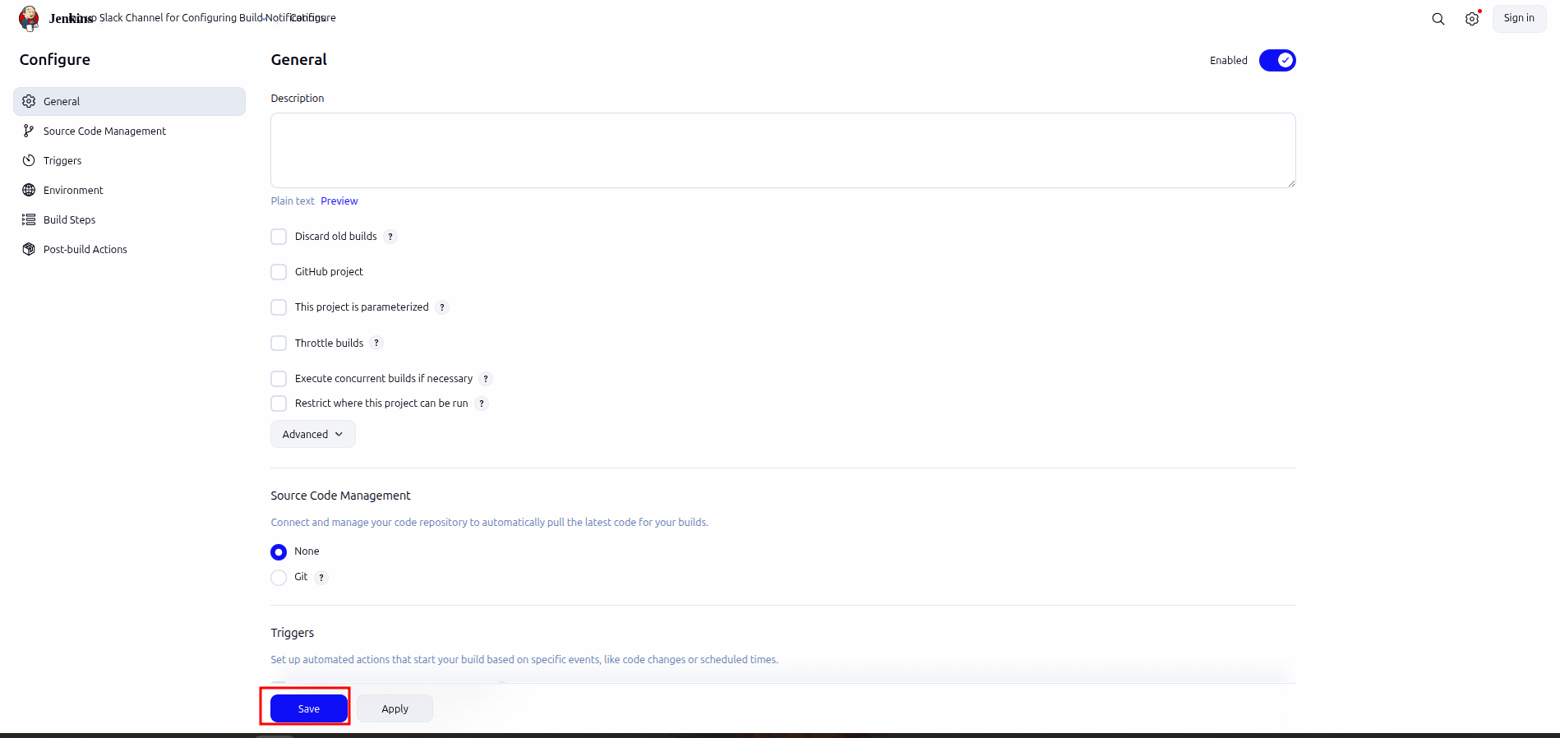

- Click on Manage Jenkins as shown in the screenshot below:
Click on Plugins as shown in the screenshot below:
Click on Installed plugins to verify whether the Slack Notification Plugin has been installed
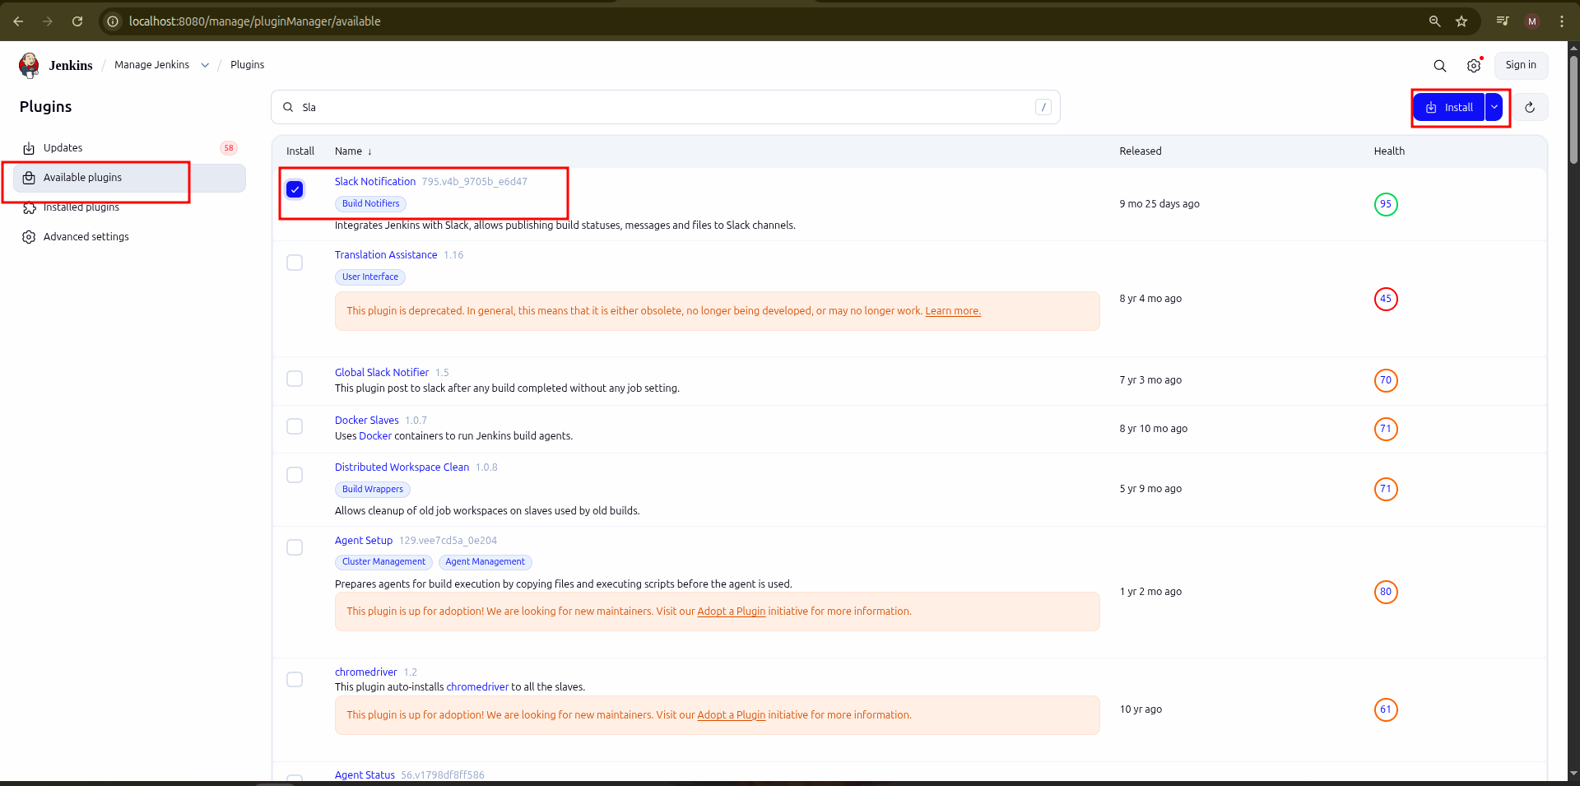

Step 2: Set up Slack channel

- Open the browser, go to Slack, enter a desired name of your company or team, and
then click on Next:
Enter a desired name for your profile and then click on Next :
Click on Skip this step:
Enter a desired channel name and then click on Next:
Click on Start with Free:
Click on the channel name that you have created:

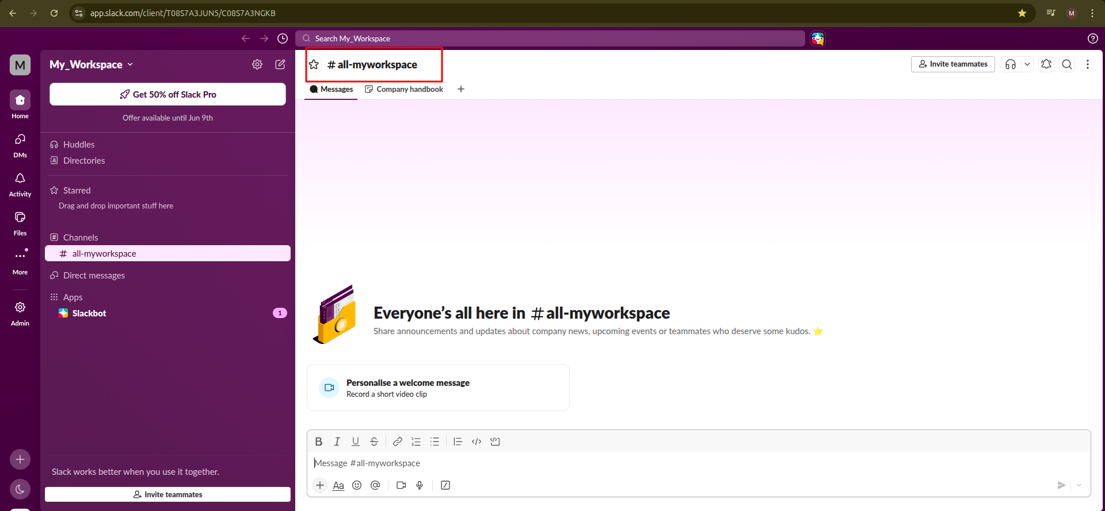

- Click on Integrations as shown in the screenshot below:

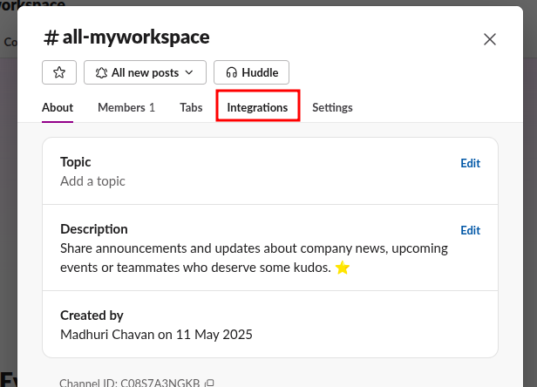

- Click on Add an App as shown in the screenshot below:

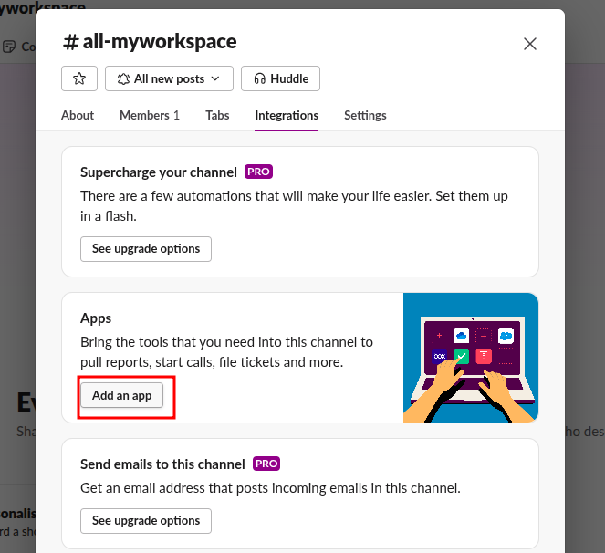

- Search for Jenkins and then click on Install as shown in the screenshot below:
Click on Add to Slack as shown in the screenshot below
Click on the Choose a channel… drop-down, select the channel that you have created,
and then click on Add Jenkins CI integration as shown in the screenshot below:

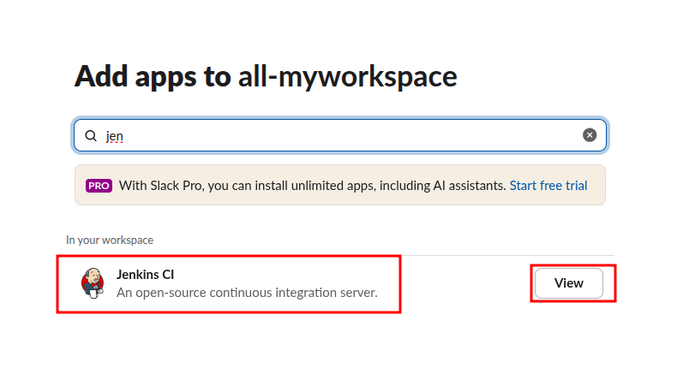

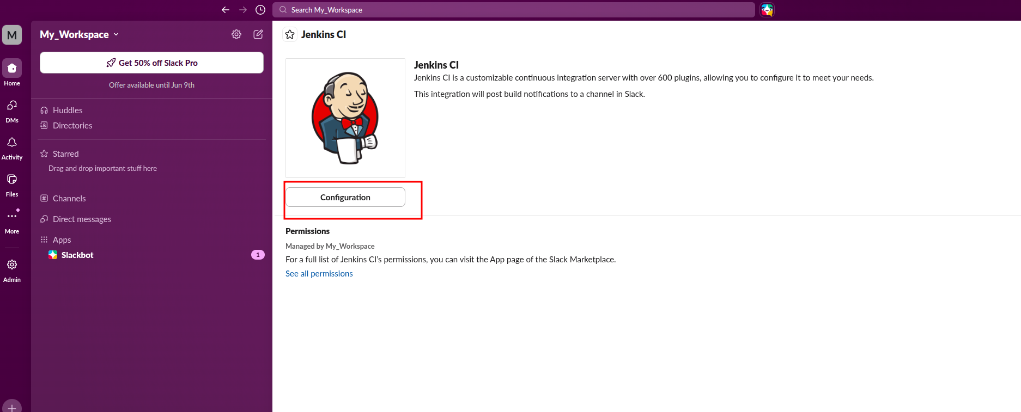

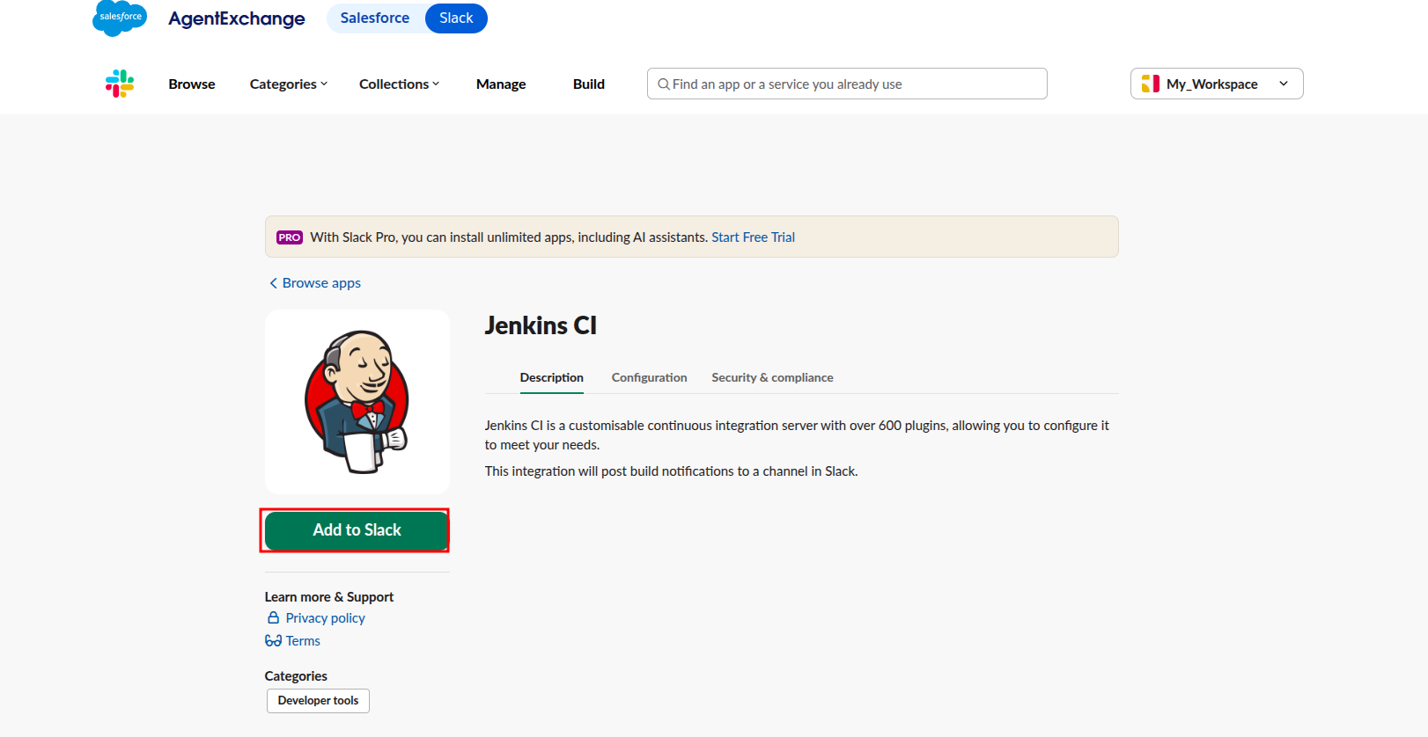

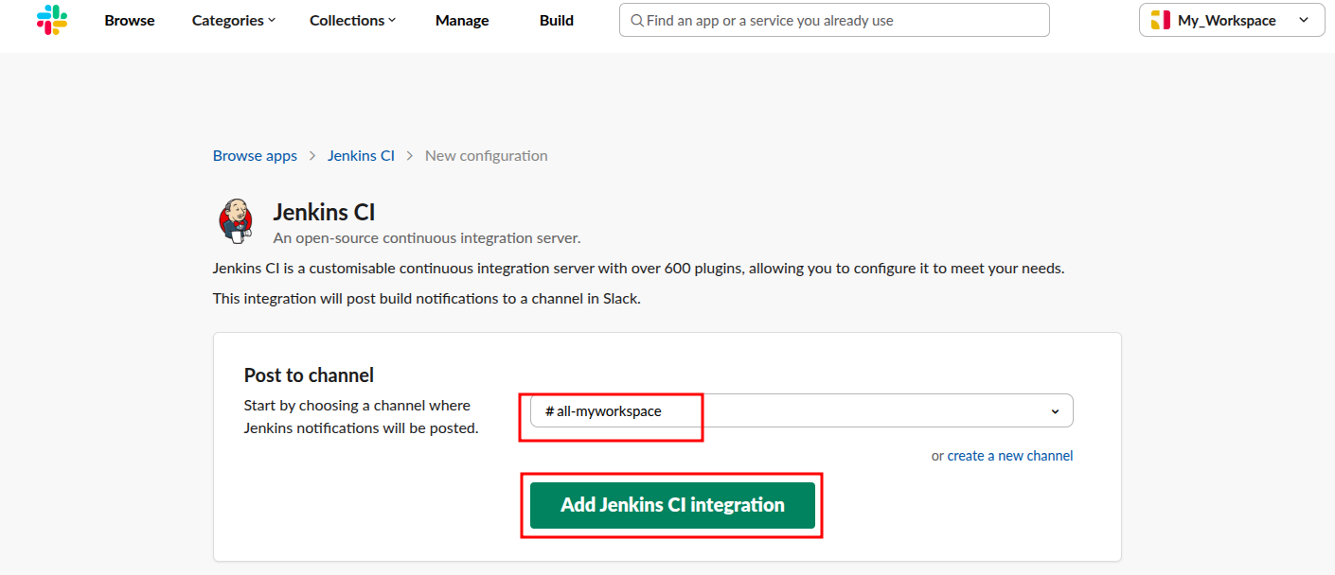

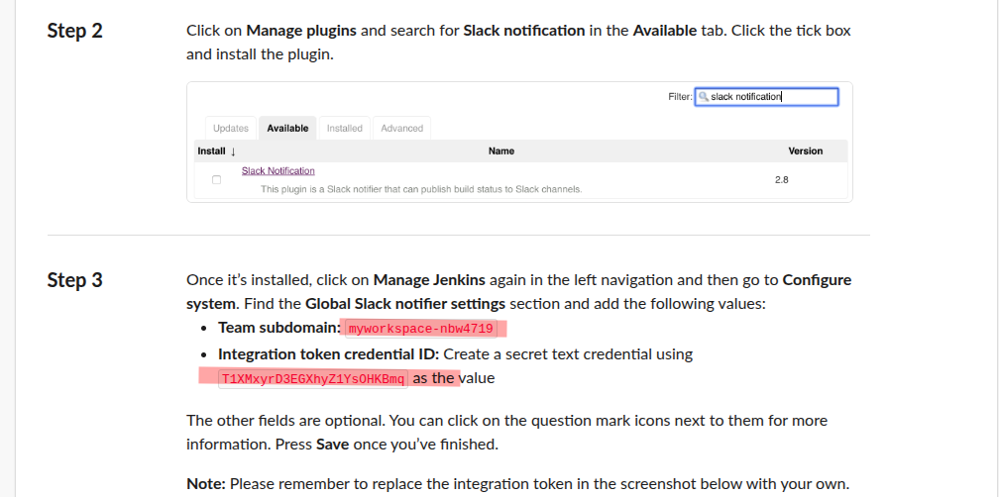

Step 3: Configure Slack in Jenkins

- Navigate into your Jenkins Dashboard and click on the Freestyle job that you have created as shown in the screenshot below:
Click on Configure as shown in the screenshot below:
Click on Post-build Actions as shown in the screenshot below:
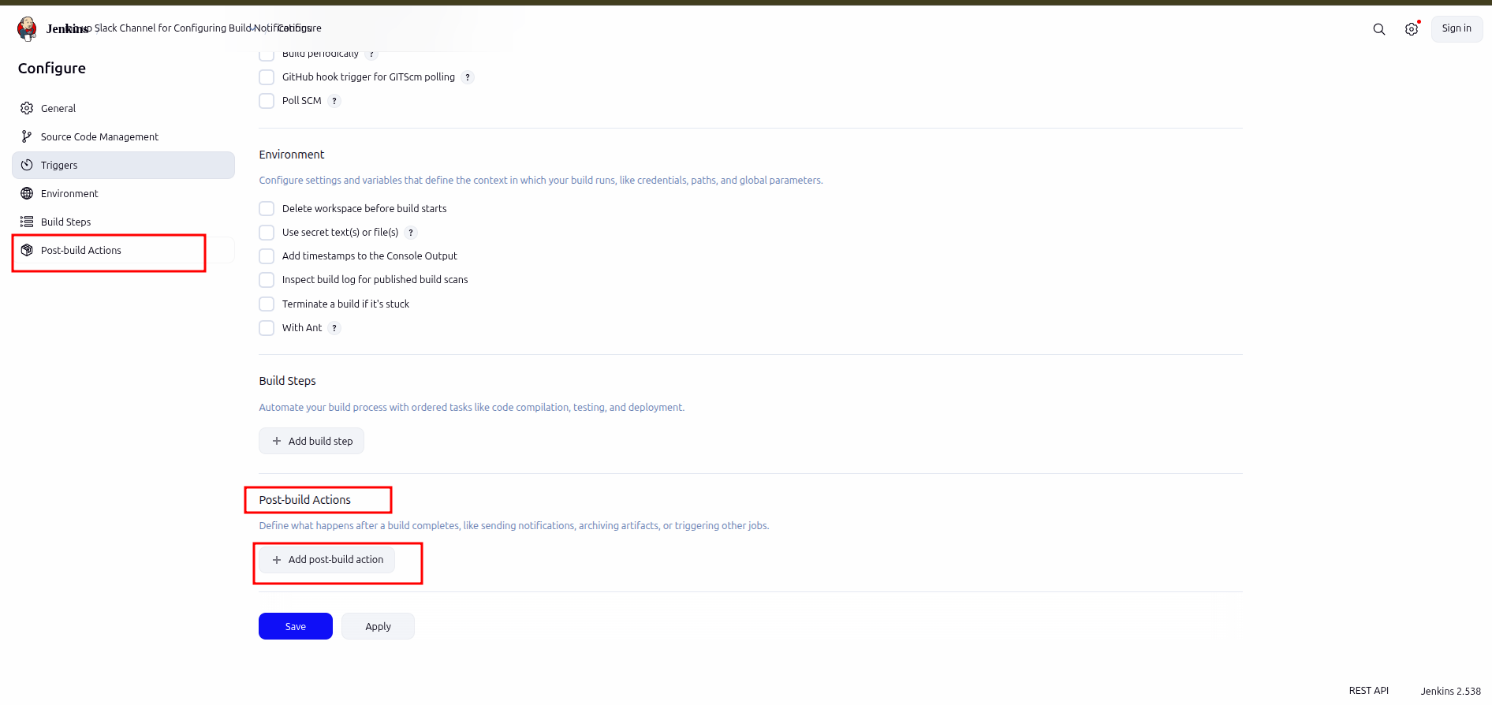

- Click on Add post-build action drop-down and select Slack Notifications as shown in the screenshot below:
Select the desired notifications and then click on Save as shown in the screenshot below:
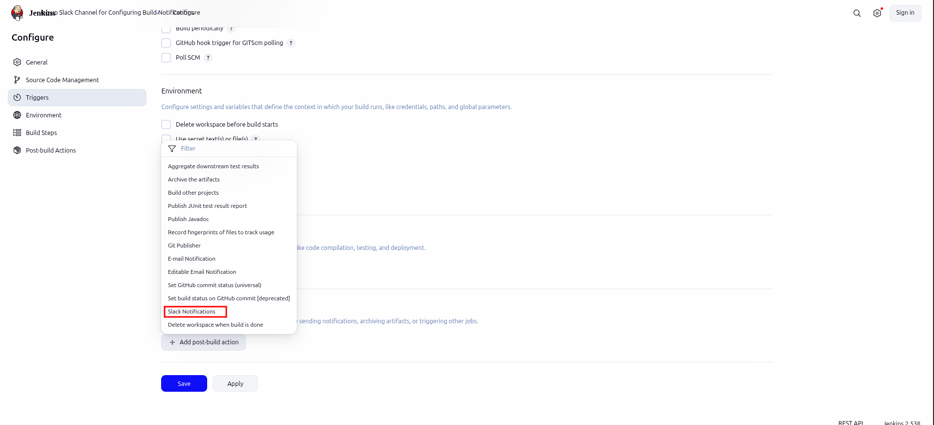

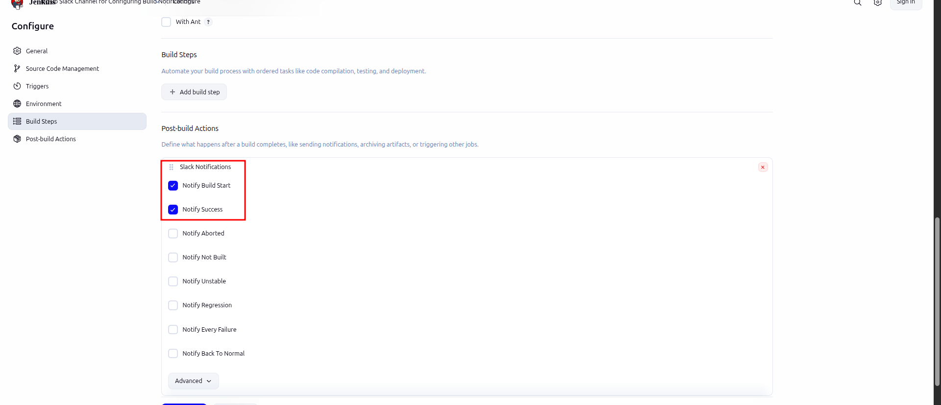

- Click on Manage Jenkins as shown in the screenshot below:
Click on System as shown in the screenshot below:
Scroll down to the bottom of the screen; under the Slack section, enter your workspace name, which is the Subdomain name, as shown in the screenshot below:
Click on Add as shown in the screenshot below:

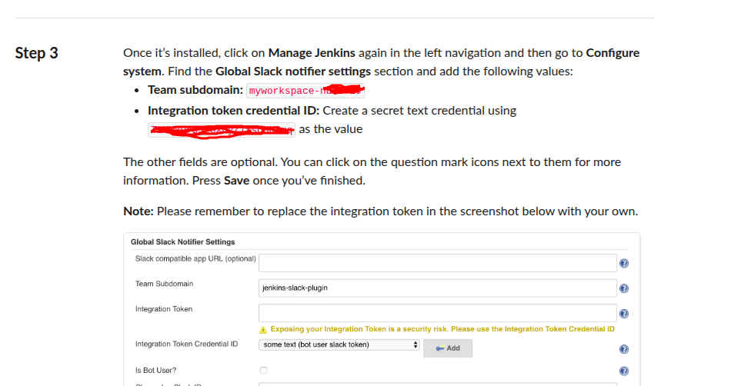

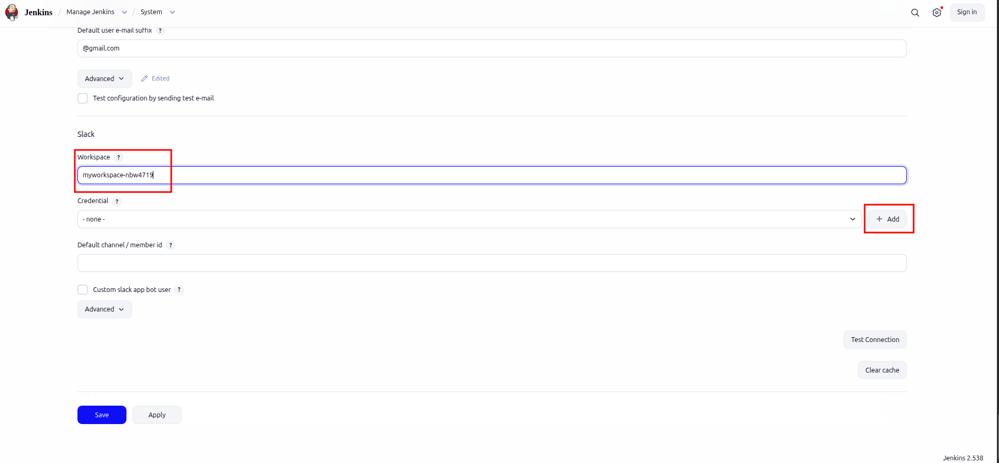

- Click on Jenkins as shown in the screenshot below:

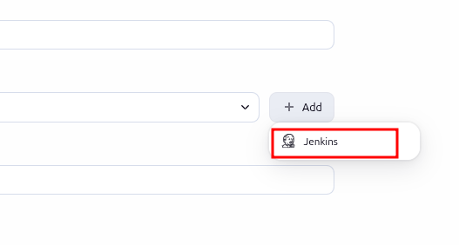

- Choose Secret text under Kind section as shown in the screenshot below:
Enter the token credential under Secret section as shown in the screenshot below:
Enter a desired name for Description and then click on Add as shown in the screenshot
below:
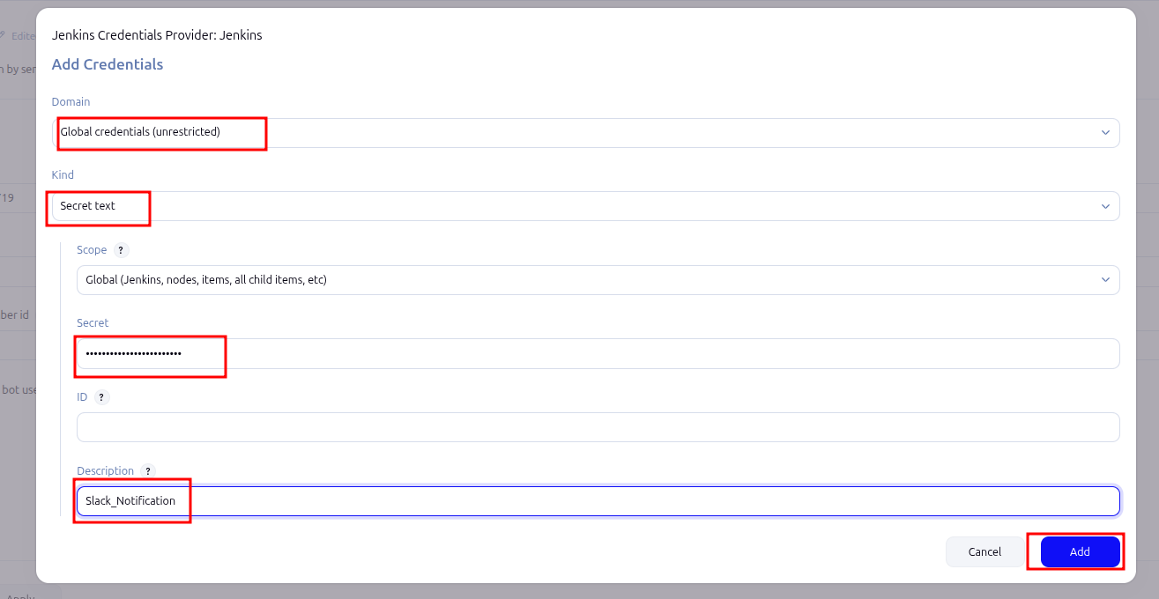

- Choose the credential name from the list that you have created as shown in the screenshot below:
Enter the name of the channel that you have created and then click on Apply as shown in the screenshot below:
Click on Test Connection to verify that the status shows Success, and then click on Save as shown in the screenshot below:
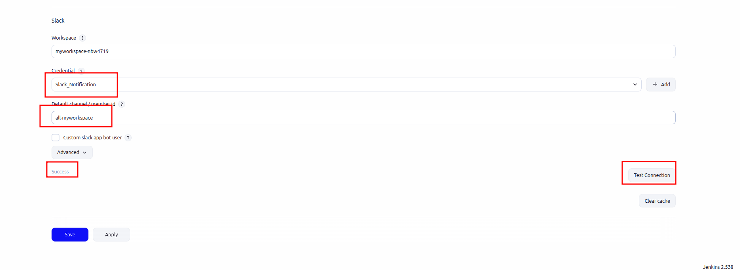

- Come to Jenkins dashboard Click on job and Build the job
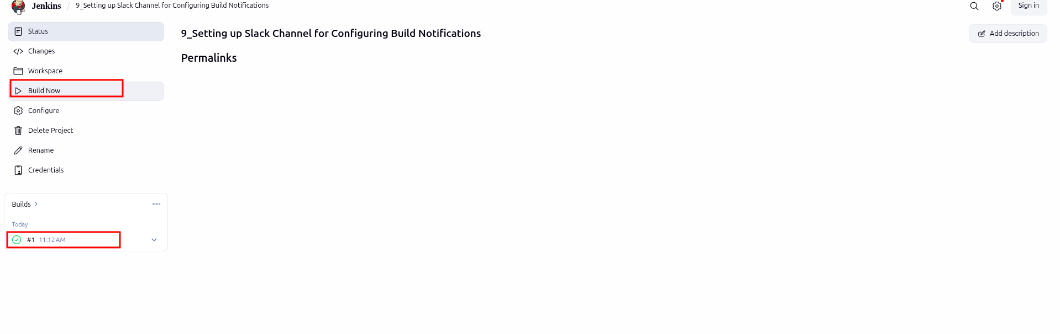

- Navigate to the slack channel that you have created and check the notification of Jenkins as shown in the screenshot below:

